FOR IMMEDIATE RELEASE
May 4, 2015

CONTACT
Nicola Beddow 202-467-2051
nicola.beddow@abc2.org

Jade Floyd 202.467.2047
jadef@casefoundation.org

RACE FOR HOPE - DC RAISES $2.1 MILLION FOR BRAIN TUMOR RESEARCH
More than $24 Million Raised Since 1998; American Idol® David Cook Returns as Honorary Chair
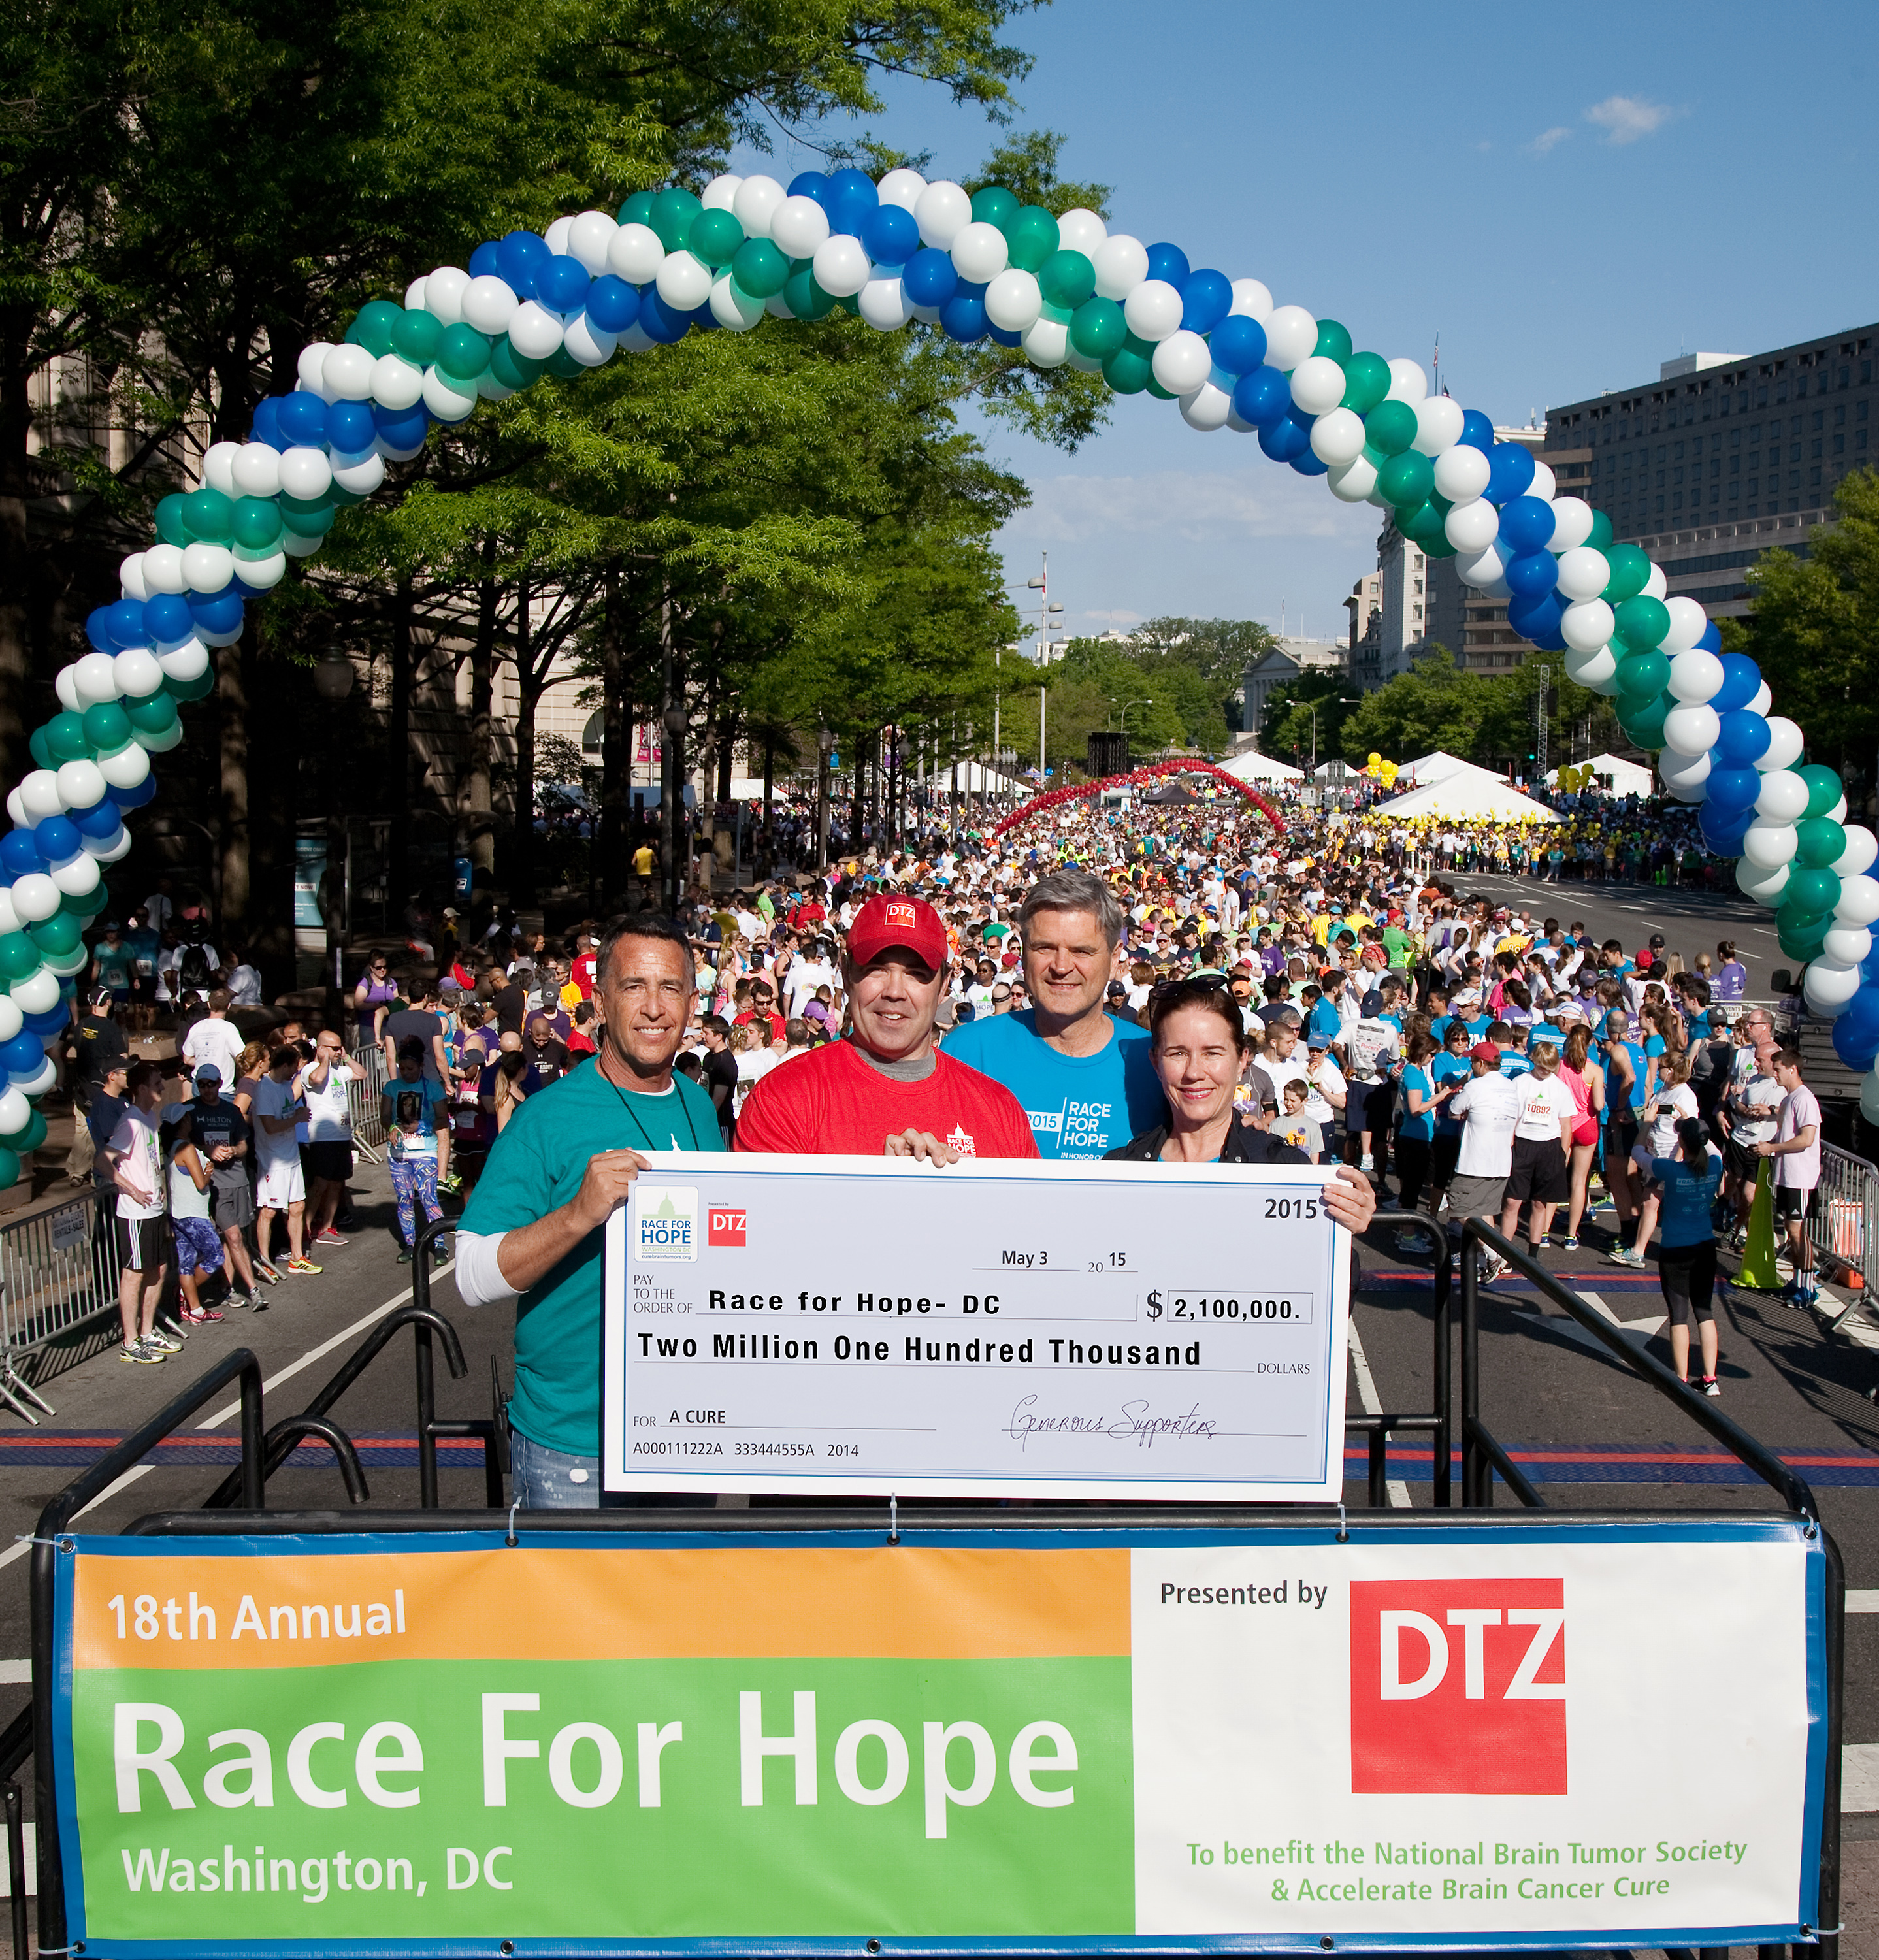
Photo: (left to right) Jeff Kolodin, NBTS; James Cassidy, DTZ; Steve Case, The Case Foundation; Stacey Case, ABC²

WASHINGTON, D.C., May 4, 2015 − On Sunday, the 18th annual Race for Hope – DC, presented by DTZ brought together more than 11,000 brain cancer advocates raising $2.1 million to benefit the National Brain Tumor Society and Accelerate Brain Cancer Cure. These organizations, as well as all of the participants, survivors, and volunteers, share the hope for a day when a cure for brain tumors exists.

The funds raised will enable Accelerate Brain Cancer Cure to fund novel translational research and investments in early-stage biotechnology companies to hasten the discovery of a cure for brain cancer. Proceeds also help the National Brain Tumor Society drive strategic research for the discovery of new brain tumor treatments and a cure, improve public policy to strengthen research, ensure access to essential health care services, and foster expedited approvals for new potential treatments.

“I love being part of the Race for Hope – DC. We’re a dedicated community committed to finding a cure for this awful disease,” said David Cook, previous American Idol® winner and Honorary Chair of the Race for Hope – DC. Cook’s “Team for a Cure” raised more than $92,000.

“We at DTZ are honored to be the presenting sponsor of the largest fundraiser for brain tumor research in the country. Our involvement started 15 years ago when my father and our local legacy firm's founder, Pat Cassidy, fell ill with a brain tumor,” said James Cassidy, Executive Managing Director, DTZ whose team raised more than $143,000 for this year’s race. “While we lost Pat in 2001, our support of this cause has only grown since then. The Race for Hope provides invaluable funding for the National Brain Tumor Society and Accelerate Brain Cancer Cure as they fund new research and support for brain cancer patients. Together we are making real progress towards a cure and improving the quality of life for brain tumor patients.”

This year’s Rabbi Joseph P. Weinberg Triumph of Spirit Award recipients include neuro-oncology nurses and doctors at Children’s National Medical Center, Georgetown University’s Lombardi Cancer Center, George Washington University’s Katzen Cancer Center, and Johns Hopkins Comprehensive Brain Tumor Center. The award honors their dedication to treating and caring for thousands of brain tumor patients in the Washington metropolitan area.

Highlights of the 18th annual Race for Hope - DC include a Survivor Tribute featuring more than 350 brain tumor survivors who marched together towards the start line as a symbol of hope and strength in their battle against brain tumors. The Race for Hope - DC is the culmination of a weekend of activities, including a benefit concert by David Cook at Acre 121 and many team-sponsored fundraising parties. These activities provide an opportunity for family and friends to honor and celebrate the lives of their loved ones, as well as provide support to each other.

Top sponsors include: DTZ, Holliday, Fenoglio and Fowler and the Conley Family, Cravath, Swain & Moore LLP, the Case Foundation, CoStar Group, Morgan Lewis, GEICO, First Potomac Realty Trust, Urban Country, 97.1 WASH-FM, and Fresh FM 94.

Since its inception 18 years ago, the Race for Hope - DC has raised more than $24 million for brain tumor research and support for those affected by the disease. Each year, the Race for Hope – DC helps to bring hope and attention to this often underserved brain tumor community. The need to increase research funding is more urgent than ever – there are almost 700,000 people living with a primary brain tumor diagnosis in the U.S. and within the next 12 months, more than 210,000 people in the United States will be diagnosed with a primary or metastatic brain tumor.

About Accelerate Brain Cancer Cure (ABC²)
Accelerate Brain Cancer Cure is focused on speeding the discovery of a cure for brain cancer. By applying an aggressive, venture funding approach not typically seen in the nonprofit sector, ABC² closes current gaps in funding in order to catalyze research and rapidly bring new therapies to patients. ABC² brings together scientists from leading research institutions and companies to drive collaboration and invest in projects, which demonstrate leadership, leverage, and impact. For more information, visit www.abc2.org.

About National Brain Tumor Society
National Brain Tumor Society is the largest nonprofit organization dedicated to the brain tumor community in the United States. We are fiercely committed to finding better treatments, and ultimately a cure, for people living with a brain tumor today and those who will be diagnosed tomorrow. This means aggressively driving strategic research and advocating for public policies, which meet the critical needs of this community. To learn more visit http://www.braintumor.org

About DTZ
DTZ is a global leader in commercial real estate services providing occupiers, tenants and investors around the world with a full spectrum of property solutions. The company’s core capabilities include agency leasing, tenant representation, corporate and global occupier services, property management, facilities management, facilities services, capital markets, investment and asset management, valuation, research, consulting, and project and development management. DTZ provides property management for 1.9 billion square feet, or 171 million square meters, and facilities management for 1.3 billion square feet, or 124 million square meters. The company completed $63 billion in transaction volume globally in 2014 on behalf of institutional, corporate, government and private clients. Headquartered in Chicago, DTZ has more than 28,000 employees who operate across more than 260 offices in 50 countries and represent the company’s culture of excellence, client advocacy, integrity and collaboration. For further information, visit: www.dtz.com or follow us on Twitter @DTZ.

Additional photos available upon request

###

