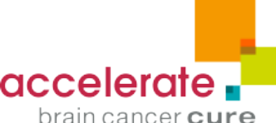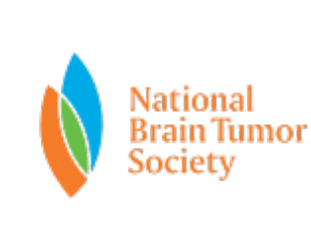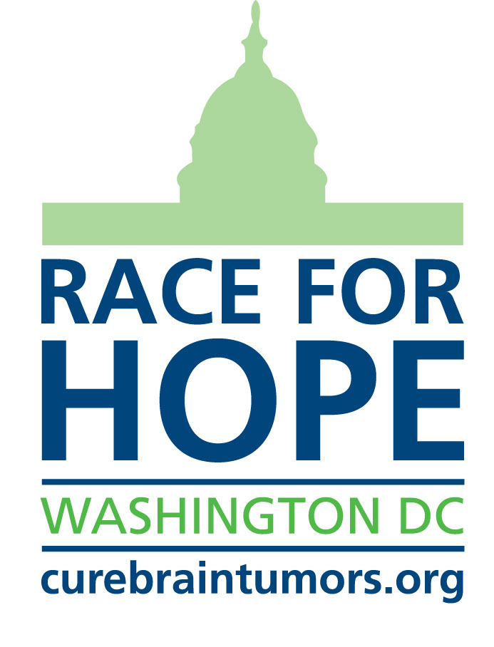

FOR IMMEDIATE RELEASE
April 16, 2015

CONTACT
Nicola Beddow 202-467-2051
nicola.beddow@abc2.org

Jade Floyd 202.467.2047
jadef@casefoundation.org

WORLD’S LARGEST BRAIN TUMOR RESEARCH FUNDRAISER, RACE FOR HOPE-DC, RETURNS TO WASHINGTON, D.C. ON MAY 3RD
More than $22 million raised since 1998; American Idol® winner David Cook returns as Honorary Chair

(Washington, D.C.) – Thousands of walkers, runners, volunteers, activists and survivors will gather in Washington, D.C. on Sunday, May 3, 2015 for the world’s largest brain tumor community event: the 18th annual Race for Hope – DC, presented by DTZ. Since its inception in 1998, the annual race has united more than 100,000 attendees and raised more than $22 million for brain tumor research and advocacy.

The Race for Hope - DC has grown to more than 12,000 participants over a weekend of activities benefiting Accelerate Brain Cancer Cure and the National Brain Tumor Society. Both organizations share a common goal: a day when there is a cure, and when all patients with brain tumors are told they have a manageable disease. Race for Hope – DC is the nation’s flagship volunteer charity fundraising event for brain tumor research. This year’s race includes close to 600 fundraising teams, and is slated to raise nearly $2.5 million.

During the post-race ceremonies, neuro-oncology nurses and doctors at Children’s National Medical Center, Georgetown University’s Lombardi Cancer Center, George Washington University’s Katzen Cancer Center and Johns Hopkins Comprehensive Brain Tumor Center, will receive the Rabbi Joseph P. Weinberg Triumph of the Spirit Award. The award honors their dedication to treating and caring for thousands of brain tumor patients in the Washington metropolitan area.

Each year, Race for Hope – DC helps to bring hope and attention to the often, underserved brain tumor community. The need to increase research funding is more urgent than ever – today, nearly 700,000 Americans are living with a primary brain tumor diagnosis, and within the next 12 months, more than 210,000 more will be diagnosed with a primary or metastatic brain tumor.

Singer-songwriter and American Idol® winner David Cook will also return for the seventh year as Honorary Chair of the event. A vocal brain cancer research advocate, Cook and his fans have raised more $1 million for research and he has spoken publicly about his brother, Adam, who lost his valiant battle with brain cancer in 2009. This year, Cook returns to the Race for Hope – DC to remember his brother and send a message of hope and resilience to the families of nearly 700,000 people living with a primary brain tumor diagnosis in the United States. “The Race for Hope is pure inspiration and I’m proud to be part of an event that brings together people who all share a common goal: an end to brain cancer,” said Cook. “We honor the memories of those who have lost their battle with brain tumors, and celebrate the survivors and family members who continue to fight the disease.” As part of his support for the race Cook will play an intimate full band acoustic concert on May 1st at Acre 121 to kick off the weekend’s events.

Highlights of the 18th annual Race for Hope-DC include: a Survivor Tribute featuring more than 350 brain tumor survivors who will march together towards the start line as a symbol of hope and strength in their battle against brain tumors; a kids’ Fun Run; and Wall of Hope. These activities provide family and friends who have lost loved ones an opportunity to celebrate their lives and provide support for each other.

The Race begins at Freedom Plaza at 13th Street and Pennsylvania Avenue (metro accessible) at 8:30 a.m. on Sunday, May 3rd, 2015. Sponsors include: DTZ, Holliday Fenoglio Fowler, the Conley Family, Cravath, Swaine & Moore, LLP, the Case Foundation, CoStar Group, Morgan Lewis, First Potomac Realty Trust, and GEICO.

Online registration for the race concludes Sunday, April 26, 2015. To register as a participant or volunteer visit www.curebraintumors.org

About Accelerate Brain Cancer Cure (ABC²)
Accelerate Brain Cancer Cure is focused on speeding the discovery of a cure for brain cancer. By applying an aggressive, venture funding approach not typically seen in the nonprofit sector, ABC² closes current gaps in funding in order to catalyze research and rapidly bring new therapies to patients. ABC² has awarded more than $20 million in brain tumor research funding to highly qualified investigators and physician-scientists from 42 institutions and companies. For more information, visit www.abc2.org.

About National Brain Tumor Society
National Brain Tumor Society is the largest nonprofit organization dedicated to the brain tumor community in the United States. We are fiercely committed to finding better treatments, and ultimately a cure, for people living with a brain tumor today and those who will be diagnosed tomorrow. This means aggressively driving strategic research and advocating for public policies, which meet the critical needs of this community. To learn more visit www.braintumor.org

###

